**50001 Ready Navigator**

The 50001 Ready Navigator is an online guide for establishing an energy management system to plan, identify, prioritize, and implement projects that will improve your facility’s energy performance. Completion of the 50001 Ready Navigator prepares facilities to pursue certification to the international best practice for energy management systems, ISO 50001.

Managing energy use in any facility is a team effort, and we are pleased you have chosen to use the 50001 Ready Navigator tool to assist you in putting an energy management system in place. Building on the structure of ISO 50001, the US Department of Energy has outlined 25 tasks with supporting guidance that your team will need to complete in order to implement a 50001 Ready system.

**50001 Ready Navigator Playbook**

The 50001 Ready Navigator Playbook is a single document resource that organizations may optionally use to their benefit as they pursue completion of the 50001 Ready Navigator 25 tasks. The 50001 Ready Navigator Playbook is structured around the four sections of the 50001 Ready Navigator and consolidates together some tasks that tend to be worked on together at the same time. As with the 50001 Ready Navigator, the 50001 Ready Navigator Playbook does not have to be completed in a linear fashion.

**Completing the Playbook**

The Playbook contains two main tabs: **Navigator** and **Playbook**. The Navigator tab contains introductory information and is for your information only. The Playbook tab contains 14 individual Microsoft Word documents. The words documents are embedded in column “N” of the Playbook. To open each Word file, users should double click on the cell containing the “Microsoft Word Document” icon as shown in Figure 1.

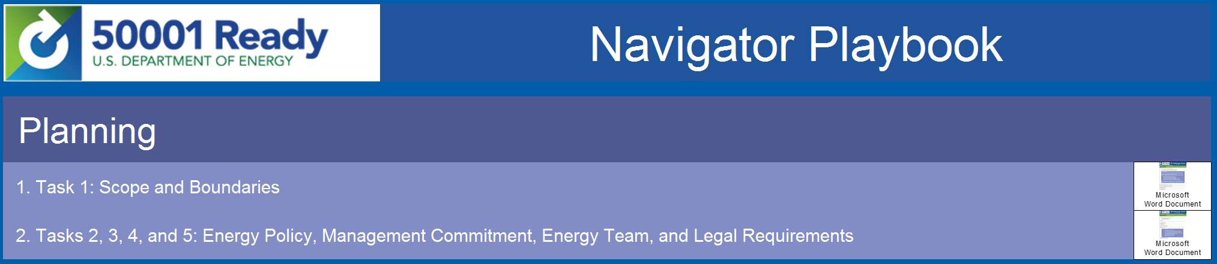

Figure 1: Opening the embedded Word documents

The Word documents are developed to act as a form, so please only fill out the highlighted areas, and mark designated check boxes if applicable. If necessary, please use the comment section at the end of each document to provide further information.

Please note that Excel will automatically keep any changes made in the embedded Word documents. The Microsoft Office Suite automatically saves embedded documents when they are closed. However, these Word documents will not be permanently saved until the main Excel file is saved. Embedded Word documents are a permanent part of this Excel file, but they can be saved individually as separate files using the "Save As" function, although it is recommended that you keep the final versions within this Excel file.

Need additional guidance? Experts at the 50001 Ready Help Desk are available to answer your questions. You can contact them at 50001Ready@lbl.gov.